Kol Simcha Torah Gazette
For parsha va’eira 5785
Volume 9 Issue 18 (Whole #432) 25 Tevet 5785/ January 25, 2025
Printed L’illuy nishmas Nechama bas R’ Noach, a”h

For a free subscription, please forward your request to keren18@juno.com
Past emails can be found on the website ShabbosStories.com under Brooklyn Torah Gazette

11 Unique Ways Jews Inaugurate Their Leaders
By Yehuda Altein

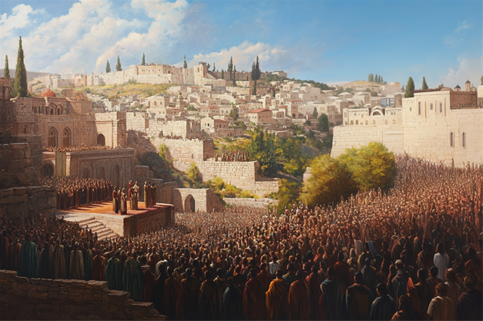

In the United States, the president is sworn into office on Inauguration Day by reciting an oath on a Bible. In the United Kingdom, monarchs are crowned in grand ceremonies featuring regalia like the crown and scepter. But how do Jews inaugurate their leaders? From kings and High Priests to rabbis and communal leaders, here’s a curious look at the unique ways Jewish inaugurations have been marked throughout history.

1. Kings of the House of David – Anointing Oil Near a Spring
When a king from the Davidic dynasty ascended the throne, a ceremony was held using the anointing oil prepared by Moses in the desert. The oil was applied to the king’s head in a circular motion, mimicking the shape of a crown. The ceremony would take place near a spring, symbolizing the hope that the king’s reign would endure like a continuous flow of water.
This wasn’t a routine event, however. Because Davidic kingship was hereditary, the ceremony was only performed when the throne was contested. Notable examples include the anointing of Kings Solomon, Joash, and Jehoahaz.
Non-Davidic Jewish kings were sometimes anointed too, but not with Moses’ special oil. Instead, they used afarsimon oil, commonly identified as balsam.¹

2. High Priests – Anointing Oil/Special Vestments
High Priests were also inaugurated with Moses’ sacred oil, applied in the shape of the Greek letter ki every day for seven days.
Toward the end of the First Temple period, the anointing oil was hidden. During the Second Temple era, High Priests were inaugurated differently—by wearing their eight vestments for seven consecutive days.
In addition to the High Priest, one other priest would receive this anointing: the one tasked with encouraging soldiers before battle.²

3. Aaron and His Sons – Unique Sacrifices
The very first priests in Jewish history—Aaron and his four sons—were inaugurated in the year 2449. Their ceremony, described in the Torah portions of Tetzaveh, Tzav, and Shemini, included anointing oil and unique sacrifices.
For seven days, Aaron performed these rituals in the newly erected Tabernacle. On the eighth day, an additional series of sacrifices marked the moment when the Divine Presence visibly appeared in the Tabernacle.³

4. Joshua – Moses’ Hands on His Head
As Moses neared the end of his life, G-d commanded him to appoint Joshua as the next leader of the Jewish people. In a public ceremony witnessed by the entire nation, Moses placed his hands on Joshua’s head. This act not only symbolized the transfer of leadership but also imbued Joshua with Divine wisdom and strength to guide the people to the Promised Land.⁴

5. Exilarch – Shabbat Ceremony
For much of the first millennium CE, Jewish life was centered in Babylonia, under the leadership of the Resh Galuta (Exilarch), a Davidic descendant with imperial authority. His inauguration, always scheduled for Shabbat, was a grand and highly anticipated event.
Before Shabbat, the main synagogue was prepared with a raised platform adorned with an ornate canopy embroidered with silk and threads of blue, purple, and red wool. During the service, the Resh Galuta sat on this platform, flanked by the heads of the great Torah academies of Sura and Pumbedita.
The cantor led the prayers, accompanied by a choir of young men, adding to the celebratory atmosphere. Following the prayers, the cantor approached the Resh Galuta to convey the community’s heartfelt blessings, marking the formal start of his leadership.⁵

6. Rabbis in Eastern Europe – Grand Reception and Sermon
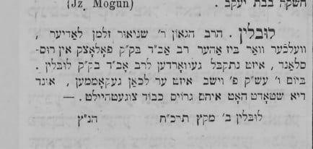
Entry appearing in the newspaper Ṿarshoyer Yudishe Ttsaytung, noting Rabbi Schneur Zalman Fradkin's Arrival in Lublin. 26 December, 1867.
The arrival of a new rabbi in Eastern European communities was a moment of great celebration. Community leaders would meet the rabbi outside the city and escort him to town, where locals, dressed in their finest clothes, waited eagerly.⁶
At the reception, the highlight was often the rabbi’s inaugural Torah sermon, known in Yiddish as the eintzugs drashah. In it, the rabbi shared original Torah insights, setting the tone for his leadership.

7. Devoted Community Members Pulling the Rabbi’s Wagon
Sometimes, the community’s excitement reached another level. As the rabbi approached the city, townspeople would unhitch the horses from his wagon and pull it themselves—a vivid expression of their respect and devotion.⁷

8. The Rabbi’s Acceptance Letter
Before a rabbi officially accepted his position, the community would send a ketav rabanut—a formal letter of invitation. Signed by the community leaders, the letter detailed their commitments to the rabbi, including his salary, honors, and other responsibilities.
These letters were often beautifully written. Some, for example, included poetic acrostics of the rabbi’s name.⁸ In a letter sent to Rabbi Avraham Yehoshua Heschel in 1800, inviting him to serve as rabbi of Apt, the community even aligned their commitments with the six orders of the Mishnah!

9. Sephardic Chief Rabbi – Ceremonial Robe

Rabbi David Yosef, Rishon L'Tzion, Sephardic Chief Rabbi of Israel

When a new Sephardic Chief Rabbi of Israel, known as the Rishon L’Zion, is inaugurated, he is adorned with a magnificent ceremonial robe, richly embroidered with gold and silver. During the Ottoman era, this regal garment was crafted in distant Istanbul and sent to Jerusalem specifically for the occasion.
Another striking tradition from the same era, though no longer practiced, involved a shochet (ritual slaughterer) slaughtering an animal at the doorstep of the Rishon L’Zion. The shochet would press his hand into the animal's blood and leave a handprint on the Chief Rabbi’s doorpost, symbolically warding off the evil eye.⁹

10. Gabbai of the Chevra Kadisha – Synagogue Procession
The Chevra Kadisha (burial society) is one of the most respected institutions in Jewish communities. In Europe of yesteryear, becoming the gabbai (honorary president) was a significant event, celebrated with much fanfare.
When Rabbi Shalom DovBer, the fifth Chabad Rebbe, known as the Rebbe Rashab, was appointed gabbai on Simchat Torah in 5648 (1887), he was accompanied to the synagogue by a jubilant crowd. A celebratory canopy was held above him, and he delivered a Chassidic discourse to mark the occasion.¹⁰
11. G-d’s Inauguration – Shofar Blasts
It’s not just human leaders who are inaugurated. Every year on Rosh Hashanah, the Jewish New Year, we proclaim G-d as our King for the coming year.
The shofar blasts serve as a key part of this “coronation,” similar to the trumpets used to inaugurate earthly kings.¹¹

Footnotes
1. Maimonides, Hilchot Klei Hamikdash 1:9–11. Hilchot Melachim 1:10–12.
2. Maimonides, Hilchot Klei Hamikdash 1:7–9 and 4:12–13.
3. Exodus 29:1–37. Leviticus 8:1–9:24.
4. Numbers 27:15–23. Rashi to Numbers 27:23.
5. Seder Olam Zuta (in Seder Hachachamim Vekorot Hayamim, vol. 2, pp. 83–84).
6. As an example, see the description of the inauguration of Rabbi Shimon Sofer as rabbi of Krakow in 1861, printed in Michtav Sofer (Jerusalem, 1952), vol. 1, “Be’er Miriam,” p. 44.
7. See, for example, Toldot HaChatam Sofer Utekufato, p. 92.
8. See Igrot Maharam Schick, pp. 70–72.
9. Harishonim L’Zion (Jerusalem, 1970), pp. 7–8.
10. Hayom Yom, entry for 12 Tevet. Likkutei Dibburim, vol. 1, p. 9–10.
11. Rabbi Saadia Gaon, cited in Abudraham (Jerusalem, 1963), p. 269.

Reprinted from the current website for Chabad.Org

Thoughts that Count

And you shall know that I am the L-rd your G-d, Who brings you out (Ex. 6:7)
The Holy One, Blessed Be He, promised the Jewish people that not only would He take them out of Egypt, but also that they would know it was He Who had redeemed them; the redemption itself would serve to deepen their understanding and faith in G-d. Indeed, this is the purpose of all redemptions and salvations: that through them we come to recognize the true Redeemer and Savior. (Sefat Emet)

And she bore him Aaron and Moses (Ex. 6:20)
The Torah specifically tells us that Moses and Aaron were born like any other mortals, to "regular" human parents; the fact that they became prophets and leaders of the Jewish nation was due to their own actions and choices, not because they descended from on high like celestial angels. From this we learn that every individual, through his own efforts and free will, can reach even the highest spiritual levels - even as lofty as Moses and Aaron. (Ma'ayana Shel Torah)

Reprinted from Parshat Va’eira 5762/2002 edition of L’Chaim

Rav Avigdor Miller on
Getting Rid of Extra Weight
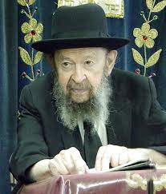
QUESTA: What should an overweight person do to get rid of his extra weight?
ANSWER: Extra weight, of course, is a chet and it comes usually from eating.
Therefore, the people of the house have to cooperate that they shouldn’t have on hand anything that’s superfluous.
I know it’s a difficult thing for the family but there shouldn’t be any cake in that house. There shouldn’t be any nuts in that house. Anything that can add weight, they should try to avoid. That’s number one.
Secondly, סיג לפרישות נדרים. Now this is very important, but you have to be careful with it. A person can make a neder every day; not a shevuah. Every day a neder. He knows he has a weakness for superfluous food. So, he makes a neder that “If I’m going to eat today between meals, I’ll have to give 50 dollars to tzedaka” – and then he chooses a yeshiva he doesn’t like.
If you’re Satmerer, “I’ll give 50 dollars to Lubavitch.” A Lubavitcher, “I’m going to give 50 dollars to Satmer.” And he should have to give it in the same week. No delay.
Only for one day. Don’t make a neder for a long time. One day at a time. נדרים סיג לפרישות. It’s a big help, by the way. For one day you could afford to make a neder like that and you’ll hold yourself back. On the second day, you’ll have more courage. Try it again for one more day. Every day try it for one day. When you feel that the taaveh is already taking hold of you, so stop making a neder for one day. The next day make a neder again until finally you get into the habit of controlling yourself without a neder.

Reprinted from a recent email of Toras Avigdor, - (based on Tape #62 – May 1996)

The Spiritual Advantage
of Blood Over Water
From the Teachings of the Lubavitcher Rebbe
Rabbi Menachem Mendel Schneerson, Zt”l

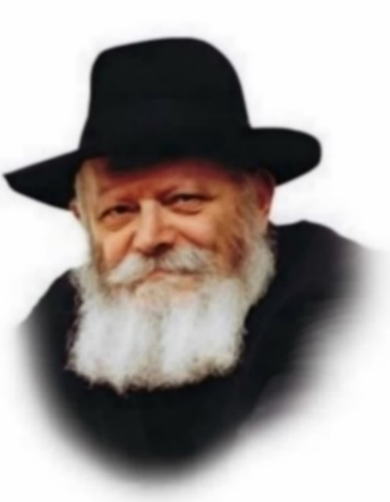

One of the reasons the Exodus from Egypt is central in Judaism (to the point that we mention it every day in our prayers) is that aside from its historical significance, it represents an ongoing spiritual process on the individual level. "Mitzrayim," the Hebrew for Egypt, is derived from the word meaning straits or limitations. "Going out of Egypt" connotes freeing oneself from anything that prevents spiritual progress, for the purpose of allowing the G-dly soul to fully express itself.

This week's Torah portion, Va'eira, describes the very beginning of the Exodus from Egypt. It thus teaches us the "first step" on the road to true spiritual liberation.
The first of the Ten Plagues was the plague of blood, in which all the water in Egypt was transformed into blood. Similarly, on the individual level, in order to free ourselves of spiritual constraints, we must also seek to turn "water" into "blood."

Water is symbolic of coldness, stillness and lack of enthusiasm. By contrast, blood is symbolic of warmth, fervor and fiery passion. If you really want to "go out of Egypt," the Torah tells us, to overcome the fetters that restrict the soul, the first thing to do is abandon your apathy ("water") and replace it with warmth and enthusiasm ("blood").

A person might claim that it is possible to be a "good Jew" even if he is not particularly enthusiastic about Jewish observance. "I already do mitzvot," he might say. "Why should I get all excited over it?"

However, the Torah teaches that coldness is the source of all evil. The true meaning of coldness is lack of interest, as demonstrated by the fact that when something truly interests us and "speaks to the heart," it is impossible to remain apathetic. If a person is "cold" toward Judaism, his actions will be dry and done by rote, even if they are technically flawless.

The key to liberating the Jewish soul, therefore, lies changing one's approach, banishing the cold and "turning up the thermostat" - learning Torah, doing mitzvot, praying, and serving G-d with eagerness and joy.

One practical way to implement this is by performing the mitzvot in the most beautiful manner possible. If a Jew's attitude is "chilly," he will be satisfied with the bare minimum. If, however, he is enthusiastic about his Divine service, he will try to observe mitzvot to the best of his ability, as he will be motivated by willingness and love rather than aiming for minimal compliance.

This, then, is the first step toward "going out of Egypt" on the individual level, which will ultimately culminate in macrocosm in the Final Redemption with Moshiach.

Reprinted from Parshat Va’eira 5762/2002 edition of L’Chaim, a publication of the Lubavitcher Youth Organization. Adapted from Volume 1 of Likutei Sichot

Rabbi Berel Wein on
Parshat Vaeira 5784

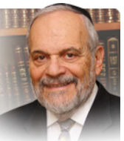

The L-rd, so to speak, according to Rashi and the Talmud, longs for the previous generations of the patriarchs and matriarchs of Israel who seemingly bore their trials and difficulties without complaint even though G-d’s revelation to them was in a lesser level than was the case with Moshe. Yet we do find that the patriarchs, Avraham and Yaakov did challenge G-d at moments of crisis.

Avraham says to G-d; “What can you grant me as I go childless?” And Yaakov says to G-d: “And You promised me that You would be good to me [and now Eisav threatens to destroy me.]” So why is the L-rd disturbed by Moshe’s statement that the lot of the Jewish people in Egypt has not yet been improved? Where do Moshe’s words differ radically from those of Avraham and Yaakov?

And why does G-d, so to speak, long for the previous generations over the behavior of the current generation? And according to the aggadic interpretation of the verses in the parsha, Moshe is punished for asking that obvious question as to why the Jewish situation has shown no improvement even though Moshe is apparently fulfilling G-d’s mission accurately and punctually. Where is the shortcoming that provokes such a critical response from Heaven?

I think that the answer perhaps lies in recognizing the difference between the individual Jew as an individual and the belief in the fate of the Jewish people as a nation and community. The individual Jew, Avraham, Yaakov, you and me, regularly face crises and difficulties in our lives as individuals. We have no guarantee that the L-rd will extricate us from our difficulties.

As Yaakov put it; “Perhaps my sins will have cancelled out any Heavenly promises of success and aid.” Avraham realizes that perhaps G-d’s promises to him can also be fulfilled through his faithful disciple and servant Eliezer. The doubts of the patriarchs are personal, not national. They never for a moment waver in their belief in the ultimate survival and triumph of the Jewish people, of the truth and justice of their cause and code, and of the validity of the mission of the Jewish people.

Moshe’s moment of complaint is not only personal, but it is national. Maybe this people will never leave Egyptian bondage. Maybe the Jewish people as a nation will not be able to come to Sinai and accept the Torah and become a kingdom of priests and a holy people. Maybe they are not worthy of the grandiose promises made to them.

Moshe is forced to account for doubting the people and implying that G-d has not chosen well, for the troubles of that people have not subsided. One can doubt one’s own place in the story of Israel. One can never doubt the validity of Israel and the Heavenly promises made to it itself.

Reprinted from the current website of rabbiwein.com

****************************************************************

And the L-rd sent thunder and hail, and fire came down upon the earth (Ex. 9:23)
According to natural law, lightening is perceived before thunder, even though they occur simultaneously. (Our sense of sight is faster than our sense of hearing; by the time the sound reaches our ears, our eyes have already absorbed and processed the lightening.) However, these laws of nature were altered during the plague of hail, and the Egyptians saw and heard the lightning and thunder at the same time.
The reason is that Moses had told the Egyptians beforehand exactly when the plague would begin; had there been a lapse between the visual and auditory components, the Egyptians could have claimed that he hadn't been precise. (Malbim)

Reprinted from Parshat Va’eira 5762/2002 edition of L’Chaim,
From a Catholic Mexican Actress on Spanish TV to a Jewish Educator in Israel
By Etgr-Lefkovits



The teenage Mexican actress stumbled upon a YouTube clip one day by a Spanish-speaking rabbi talking about how to find happiness through the Bible.
The video would change Hannah Abitbul’s life forever.
The 18-year-old who was used to doing TV commercials and soap operas on Telemundo—an American Spanish-language channel owned by a division of NBCUniversal—quickly ordered a Bible on Amazon and started reading it, trying to grasp the lofty biblical concepts after having been raised as a Catholic in a secular household.
Always Curious
Although she was born into the world of television acting and commercials as her mother worked as a booking agent for a modeling agency, she was always interested in Judaism, even as a little girl.
What do you do on the Sabbath?” she would ask the secular Jews working as producers or photographers at her work. “We light the candles,” they replied to her, she recounts in an interview with JNS in Tel Aviv.
Still curious, she sought out more information online about Judaism, including learning about keeping kosher, as she pondered theological questions about the source of her own religion.

Synagogue Near Me”
After buying her Bible, Abitbul decided to seek spiritual guidance and searched on Google for “synagogue near me.”
She visited the synagogue in Mexico City that came up on the web, and at the entrance she gave the Mexican name she was born with. The local security guard told her she could not come in for security reasons. However, the employee, who was new on the job (and didn’t know much about Judaism himself) agreed to take her number and give it to the rabbi since he heard that the synagogue had been looking for a minyan, a public quorum of 10 men required for public worship.
Some days later, the rabbi called her back and said he didn’t understand what she had wanted but agreed to meet her. Abitbul told him that she was interested in converting, but he replied that at 19, she was still very young, could decide later that it wasn’t for her.
Today, you will want Judaism, and tomorrow, Buddhism or vegan,” he told her.
Insisting that she was studying Judaism, the rabbi asked her what Jews eat on Yom Kippur, the Day of Atonement (a fast day). “I don’t know, but I like to cook,” she replied.
Not surprisingly, the rabbi was unimpressed.

Her First Shabbat
Undeterred, she kept phoning him until he agreed that she come to a Friday-night service. The congregants were already in the middle and she said she was “mesmerized” by the songs welcoming in the Sabbath.
I felt like I knew the song, even though I had never heard it in my life,” she said.
She persisted in keeping in touch with the rabbi and began going to courses in Judaism at the synagogue after work to prove that she was serious.
The rabbi asked the teenager if her parents were aware of her Jewish studies, and when she told him no—that they were sure she was at parties on Friday nights—he insisted that she tell them.
Abitbul told her mother that she had something important to tell her, and the two met for sushi lunch. Her mom had no clue what was to follow. Upon hearing that her daughter wanted to convert to Judaism, she was shocked, and after first assuming that it was because of a Jewish boyfriend, insisted on meeting the rabbi and his wife to be sure her daughter was not involving herself in a cult.
After a cordial meeting with them, her mother relented.


At Aish in Jerusalem

Off to Israel
The next major surprise for her parents came when she told them that she wanted to study in Israel, where the rabbi told her she could learn and eventually undergo a conversion.
Her family, who thought that Israel was only about war and terrorism, refused to help her financially. Abitbul paid her own way from her earnings in acting.
After three months studying at a Jerusalem girl’s seminary in 2017, she returned to Mexico because her mother had fallen ill with cancer, passing away the following year.
After her mother’s death, Abitbul reconsidered whether it was right for her to return to Israel as she had planned. Her older sister told her to do what made her happy and not to stay in Mexico because of the family.
Abitbul returned to Israel. A year and a half later, she completed her conversion process, which happened on the very weekend of the Jewish holiday of Shavuot, which marks the giving of the Torah at Mount Sinai.
Ironically, around the very time she finished her conversion, her cousins who were applying for a Spanish passport had discovered that her father’s family from Spain—completely unbeknown to him—were Anusim, Jews who were forced to convert against their will.
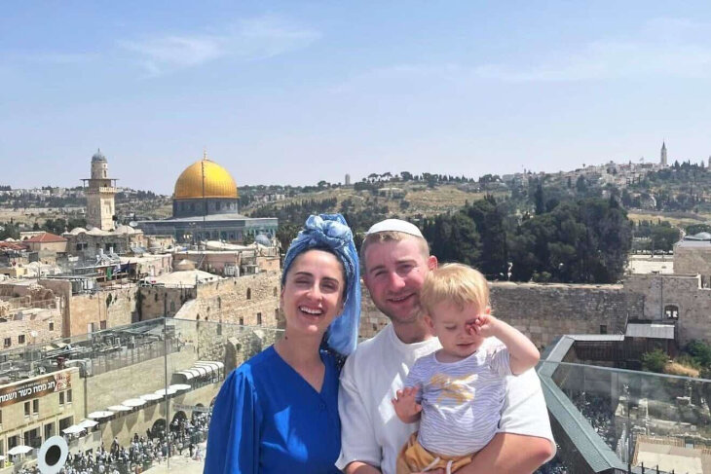
With her husband and their young son in Jerusalem.

New Life and New Family
Shortly after converting, Abitbul, 27, met her future husband, Avishai, on a popular Israeli dating app that caters to the traditional and religiously observant (her husband became religious himself on a post-army trip to India). Today they are proud parents of a two-year-old son.
He is 100 percent non-Spanish-speaking,” she said of her husband, noting that his family in the Israeli coastal city of Ashkelon, not far from the Gaza Strip, wondered aloud during the war how she had left the beaches of Mexico for a tumultuous life in Israel.
Abitbul's passion and unique story caught the attention of the folks at Aishlatino.com, Aish’s Spanish site. They invited her to create video clips about Jewish holidays and Judaism for Spanish-speaking audiences.
It was always natural for me to be in front of the camera,” she says. “We need to be proud of our Judaism and who we are.”
Her videos took off, garnering quite a large following. Today, Abitbul plays a key role in running Aishlatino’s social media. With over 300,000 followers on Tiktok and 100,000 followers on Instagram, she is responsible for bringing Jewish wisdom to hundreds of thousands of people around the world and getting a whopping 275 million video views of the past two years. Hannah Abitbul has certainly found her home.

Reprinted from the current website of aish.com. A version of this article originally appeared on JNS.

